

Individual Healthcare Plan (IHP) England, Wales, Scotland /

Individual Education Plan (IEP) Northern Ireland

For any child or young person with arthritis or being seen by the rheumatology team

FOR USE IN NURSERY, SCHOOL, COLLEGE OR ANY EDUCATION SETTING
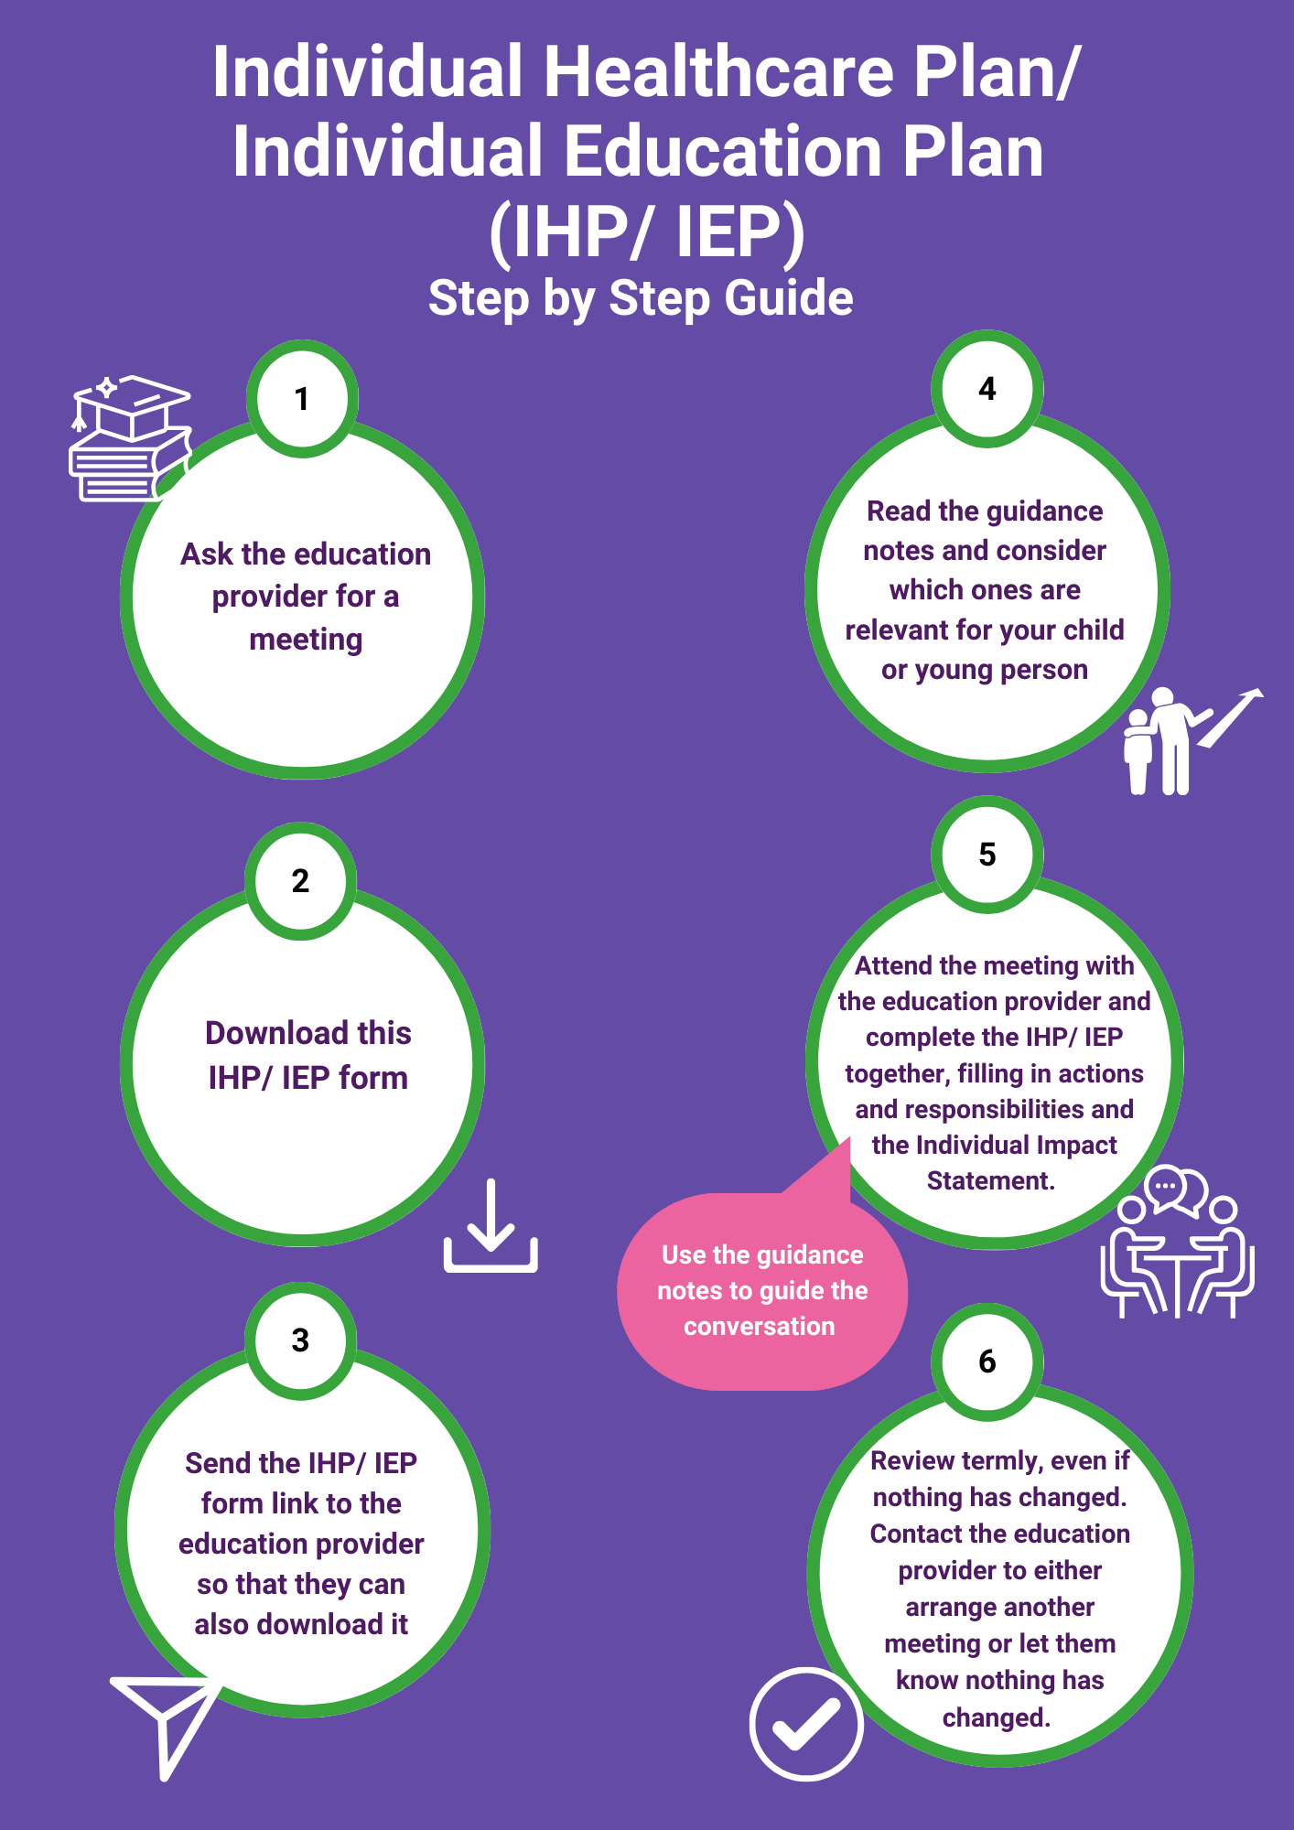

Dear families,

Welcome to your Individual Healthcare Plan/ Individual Education Plan (IHP/ IEP).

Any child or young person with a medical condition is entitled to an IHP/ IEP. The plan is designed to help your child or young person whether they are at nursery, school, college or any other education provider by outlining any additional support they may need- this might include practical, physical, social or emotional support.

The best way to put this IHP/ IEP in place would be through a meeting with the education provider. You may also wish to invite a healthcare professional from your child or young person’s rheumatology team to attend with you. Involving your child in the development of the content is important too.

Many education providers use a standard generic IHP/ IEP form. Families, healthcare professionals and teachers have found that the standard IHP/ IEP form is not always the best fit for children and young people with these conditions. Therefore, this specifically adapted version of the form for children and young people living with rheumatic conditions has been developed across several charities in collaboration with education providers, healthcare professionals, parents and young people.

In this pack you will find:

- An Individual Healthcare Plan/ Individual Education Plan (IHP/ IEP) form for rheumatic conditions.
- Guidance Notes. (including tried and tested solutions that have helped other children/young people)
- Flow chart (to guide you through the process).
- Some additional information about the rheumatic condition Juvenile Idiopathic Arthritis (JIA) that might be useful. If your child has a different rheumatic condition, please contact your healthcare provider for appropriate information.
We hope that you find this useful – if you require any additional support or advice in the process of setting up this IHP/ IEP, please contact any of the charities below.
Best wishes,
CCAA – Kids With Arthritis, JIA at NRAS and Arthritis UK


Dear Education Provider,

Children and young people with arthritis or any other rheumatic condition may experience disease symptoms and medication side effects that affect their education and attendance. Living with a long term health condition may also impact their wider school experiences, friendships and wellbeing; it’s important to consider what physical, social and emotional support may be needed for a child or young person.

Families, healthcare professionals and teachers have found that the standard Individual Healthcare Plan/ Individual Education Plan (IHP/ IEP) form is not always the best fit for children and young people with these conditions.

By using this specifically adapted IHP/ IEP, you can ensure children with rheumatic conditions are properly supported so that they can play a full and active role in school/nursery/college life, remain happy and healthy and achieve their academic potential. Attached you will find:
- The specifically adapted version of the IHP form for rheumatic conditions.
- Guidance Notes (including tried and tested solutions that have helped other children/young people)
- Some additional information about the condition

The IHP/ IEP form is to be completed with the family at a face-to-face meeting. In some cases, it might be appropriate to invite relevant healthcare professionals to attend.
Please bear in mind that the conditions themselves may vary greatly from one individual to another. However, all children and young people with rheumatic conditions want to be treated as ‘normally’ as possible while being supported appropriately by the school.

Rheumatic symptoms can often fluctuate and can be unpredictable from one day to the next. Children and young people may go through periods of remission but they may also experience flares (a sudden worsening of symptoms). It is important that this healthcare plan is reviewed regularly to make any necessary changes to the support required. Two-way communication with the young person and their family is key. Having a key point of contact within a school works well.

Many thanks in advance for the important role you will play in supporting this child or young person throughout their educational journey. If you require any additional advice in the process of setting up this IHP, please contact any of the charities below.

Best wishes,
CCAA – Kids With Arthritis, JIA at NRAS and Arthritis UK

Part 1. CONTACT DETAILS
Full name of child/young person
Date of Birth
Home Address
Name of Parent / Carer
Telephone Numbers (home/work/mobile)
GP Name and Address
Consultant Name/s and Treatment Centre
Any other key contacts
Main contact person in school

Part 2. MEDICAL CONDITION DETAILS
Diagnosis
Details of medication given at home/hospital (please also mention here any side effects that may be experienced)
Details of any medication needed to be given at school/college

Individual impact statement
What does the rheumatic condition mean for the individual within the education setting currently?
Use this space to summarise discussions:

Part 3. Table of actions arising from discussion (please copy extra pages as required)
TOPIC | ACTION REQUIRED | BY WHOM | DATE TO BE REVIEWED
Examples:  Learning / Equipment in class  School Environment | Subject teacher to supply extra copy of textbook.  Lift pass and friend/buddy to help carry bags | Subject teacher  Responsible member of staff

 | Name | Signature | Date
Child/Young person
Parents/Carers

School representative

Healthcare Professional (if present)

Date for IHP review :

Guidance Notes

Please use this list as a prompt for discussion to complete the Individual Healthcare Plan/ Individual Education Plan (IHP/ IEP) form. Each topic has suggested ideas that have helped other families. Some topics may be more relevant than others at different times in the child/young person’s educational journey. Please add topics not covered. You’re not expected to be an expert in arthritis, but we encourage you to read up on the relevant type of arthritis on trusted websites (we’ve included some links at the end of this pack). And more importantly speak to young people and parents/carers about their individual needs and experiences.

Medication and Side Effects
What medication is the child on? What side effects are experienced? Going through any medication changes or difficulties? What should staff be aware of? Consider:
- A toilet pass if medication affects stomach
- Water breaks more often if medication increases thirst
- Possible nausea on injection day and strategies used to cope etc.
- Side effects if on steroids (may include: weight gain, puffy face, mood swings, irritability, 'hyper' outbursts or any other symptoms)
- Any coping strategies for side effects
- Being aware of anxieties around taking medication; medications not working as hoped or changes in medication - which may affect mood.

Hygiene, First Aid and Infectious Diseases
Is the child on a medication that would reduce their immunity?
Consider:
- School to notify parents of infectious diseases e.g. chicken pox, scarlet fever so that parents can look out for symptoms or get anti-viral medication if necessary.
- All cuts to be thoroughly cleaned and covered to avoid infection, notify parents of any bumps/sprains etc.
- Anti-bacterial hand gel kept in class and used regularly, help with hand-washing if needed.
- A designated person to help apply additional sun cream at regular intervals, dependent on age/ability (some conditions and some treatments mean an increased vulnerability to the sun).

School Environment
Are there any issues with moving around the building or accessing classrooms on upper floors?
Consider:
- Lift pass
- Lessons on ground floor
- Extra time to move between classes
- Easily accessible locker
- Assistance with using mobility aids in school (e.g. wheelchair, crutches etc.)

Uniform
Does the child/ young person need any adaptations to the uniform? Are there issues with getting changed at school?
Consider:
- Shoes – supportive, comfortable and with space for orthotics (podiatrist may have recommendations)
- Shirts & blouses- buttons/ poppers
- Additional time for changing
- Permission to come into school in P.E kit on P.E days

Learning / Equipment for class, homework or coursework
Is there any impact on learning in class? Can this vary over the day e.g. more stiff and sore in the morning? Is an Occupational Therapy assessment needed?
Consider:
- Is fatigue an issue?
- Are some times of day trickier than others?
- Adaptations to learning through play at school (for younger children)
- Does the timetable need adjusting?
- Access to laptop
- Ability to move around when needed
- Agreed way for child to indicate when they need time out
- Is any specialist equipment needed?
- Positioning of chairs/desks
- Option to sit on a chair i.e. during assembly or carpet time
- Adapted pens/pencils
- Scribes
- Format of homework
- Extra set of books to be kept in school to avoid carrying them backwards and forwards to home

Physical Activity
What would enable the child/young person take part fully in sports/ physical activities?
Consider:
- Agree how staff will be notified if there are problems on a day or week.
- Are there any red flag activities? (Physiotherapist might have suggestions)
- Rest breaks (how to ask for these)
- Can lessons be adapted discretely- high impact vs. low impact
- Additional time for getting changed or somewhere private to change
- The impact of weather conditions on participation e.g. cold, wet

Mealtimes
Are there any special requirements during meal times?
Consider:
- Medication
- Queue pass to avoid standing
- Adapted cutlery

Exams and coursework
Approaching internal or external exams, might any additional support be needed?
Consider:
- Extra time needed
- Laptop/ equipment (including typing practice)
- Software e.g. speech recognition
- Scribe
- Space to move around
- Rest breaks
- Has the child/ young person practiced using any additional support tools?
- When do you need to apply to exam boards for additional support requests?

School Trips
What might be needed on short outings, day trips, regular trips e.g. to swimming pool or sports field, and longer residential trips?
Consider:
- Trained and additional staff on trip
- Accessible room if overnight
- Storage for medication e.g. refrigerator, sharps bin
- Lifts/ wheelchair if too far to walk
- Consideration of distances and length of activities
- Assistance carrying bags or equipment
- Shade/ shelter from the sun

Social/Emotional needs
Does the child/young person have any social /emotional needs that the school could help with?
Consider:
- Counsellor
- Buddy system
- Support from school nurse
- Support staff or designated teacher who knows them well as a ‘go-to person’
- Use of code word or card to tell teacher they are in pain or need a rest.
- Do they have close friends who help them cope?
- Support to address bullying.
- Support to communicate with peers/ school community - raising awareness about arthritis. Not all young people will want this, but it’s worth considering due to the stigma around being young and living with arthritis.

Communication
What is the best way for parents, young people and education providers to communicate with each other?
Consider:
- Via email
- Notebook
- Form tutor
- Phone call
How can the student alert teachers to issues without drawing unwanted attention?
How will education providers communicate information to ALL staff (including supply staff) involved with that child/young person?
How will education providers communicate when transitioning from one establishment to another?

Absences
Rheumatic conditions may require absence due to medical appointments, treatments and illness.
Consider:
- What regular appointments might the child/young person have?
- Who will take responsibility for helping them catch up any missed work?
- Buddy system for missed work
- Opportunity for remote learning
- Absences through medical appointments not to count against attendance
- One to one tutoring
- How to ensure child/young person is not unfairly penalized for absence in e.g. attendance award scenarios

Staff Training
Is any staff training required?
Do you require any additional information from:
- Young person and their family
- Healthcare professionals
- Charities

For further information
 | Website | Information
 | https://www.ccaa.org.uk/ | CCAA - Kids With Arthritis are a volunteer-led charity supporting children, young people and families across England, Wales and Northern Ireland. We mainly cater for those aged 0-16 along with their families. We have 4 main strands of support for families:  - Residential Family Activity Weekends  - Local Area Support Groups  - (roughly 1 per county across England and Wales, run on Facebook, supported by our local area parent reps)  - CCAA Award Badge Scheme  - (8 different badges to collect: Courage, Effort, Supportive Sibling, Active Achievement, Research, Fundraising, Raising Awareness and Next Steps)  - Online and Downloadable Resources
 | https://www.arthritis-uk.org/information-and-support/understanding-arthritis/young-people-and-families/ / | We are a UK-wide charity supporting people of all ages living with arthritis – with dedicated work focused on children, adolescents, young adults and their families. We also have a dedicated Young People and Family Service – with a team of staff working in partnership with NHS specialist rheumatology centres across the UK to provide 121 support advice and guidance in hospital settings and communities.
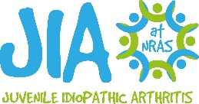 | https://jia.org.uk/ | The National Rheumatoid Arthritis Society (NRAS) was founded in 2001 and is the only UK charity specifically devoted to supporting adults and their families living with rheumatoid arthritis (RA) and children, young people and their families affected by juvenile idiopathic arthritis (JIA), and the health professionals treating RA and JIA.  Due to NRAS’ targeted focus on these two conditions, RA and JIA, the society provides truly expert and wide-ranging services to support, educate and campaign for people living with and impacted by these complex auto-immune conditions.
 | https://lupusuk.org.uk/what-is-lupus/ | LUPUS UK is the only national registered charity supporting people with systemic lupus and discoid lupus and assisting those approaching diagnosis. We presently have over 5500 Members and a number of Regional Groups around the UK who arrange medical talks, publish local newsletters, set up local occasions and organise fundraising events.  LUPUS UK also produces an informative national magazine with lupus articles, letters, reports, and photographs, and operates a strong Grant Programme for research purposes and welfare.
Government guidance on supporting pupils in education settings with medical conditions
England | https://assets.publishing.service.gov.uk/government/uploads/system/uploads/attachment_data/file/803956/supporting-pupils-at-school-with-medical-conditions.pdf  http://www.medicalconditionsatschool.org.uk/
Scotland | https://www.gov.scot/publications/supporting-children-young-people-healthcare-needs-schools/#page-top
Wales | https://www.gov.wales/sites/default/files/publications/2018-12/supporting-learners-with-healthcare-needs.pdf  https://www.gov.wales/supporting-learners-healthcare-needs-0
Northern Ireland | https://send.eani.org.uk/what-sen

